# Stakeholder Questions

1. What is your current solution for soil compaction?

* Prompts: Do you send someone to the field to manually monitor or is there any other source of “ground truth”.
* Why: Eventually we may want to test and validate results for effectiveness and/or accuracy of IoT solution. Can also compare (time trial) how long the alternative takes

1. Do you currently track how much time you spend measuring soil moisture or dealing with the fall out (bogged equipment) of the effects of soil compaction?

* Why: So we can find out how much time, resources it takes, how often it occurs and good point of comparison. Goal is not to create more work when solving the problem.

1. Do you foresee any challenges with implementing IoT solution?

* Prompts: Would you be ok with dispersing these sensors. If an IoT solution is provided, can you place them so that your existing equipment will not ‘run over’ them.

1. When you open the map on John Deere Platform, for each paddock we imagine there will be multiple IoT Sensors, currently we’re thinking of sending through the Location data of the sensor and the last reported Soil Moisture level (early morning or midday).

Would you also like to have a recommendation on the John Deere Dashboard that suggest whether it’s safe to operate heavy machinery or not?

* Why: User Experience information so that we know what information is required and how best to display it. See Example below.

**Example from John Deere Platform -** [**Source**](https://developer.deere.com/dev-docs/assets)

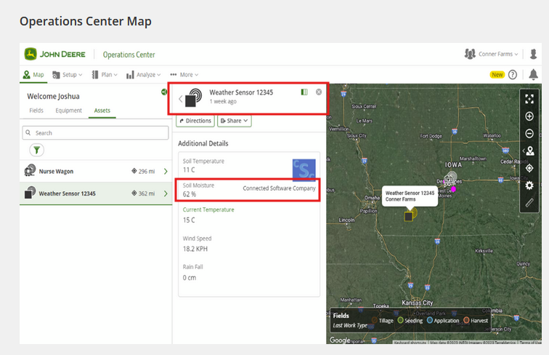

1. At this stage or any other stage of the project do you have any comments or things that we need to consider or any challenges that we may need to solve?